Discover Applied Sciences

Review

Review on music emotion analysis using machine learning: technologies, methods, datasets, and challenges

Sheetal Patil¹ · Rudragoud Patil¹ · Shweta Goudar¹ · Sangeeta Sangani² · R. H. Goudar³

Received: 30 January 2025 / Accepted: 19 May 2025
© The Author(s) 2025 OPEN

Abstract
In recent years, the language of emotion has attracted widespread attention in music therapy. Each piece of music inherently carries an emotional essence, making the study of music emotion crucial. This work begins by exploring the historical background of music emotion and then conducts a comprehensive survey of existing machine learning, deep learning, and ensemble techniques employed in music emotion detection, along with a detailed analysis of the datasets utilized in these methodologies. Additionally, we identify and discuss the key issues and challenges emerging from our survey. Our work also delves into the contemporary technology of music emotion detection, focusing specifically on elec- troencephalography (EEG) signals. Lastly, we outline potential avenues for future research in music emotion detection.

Keywords Machine learning · Emotion detection · Music therapy · Electroencephalography

Introduction
Music listening rates have significantly increased in recent years due to advancements in technology and the wide- spread availability of digital music platforms [1, 2]. This surge in music consumption has had a profound impact across various fields, particularly in healthcare where music is increasingly recognized for its therapeutic benefits [3], which helps in treating a wide range of conditions such as anxiety, depression, chronic pain, and cognitive disorders [4]. In some of the recent research works, it has been shown that listening to music can enhance mental function, improve mood, reduce stress levels, and even aid in physical rehabilitation [5–7]. Moreover, as emotions play a crucial role in music, shaping how individuals perceive and respond to different musical compositions has become important for music recommendations [8]. This is where Ekman’s Six Basic Emotions Model (1992) views emotions as discrete and universal, while Thayer’s model distinguishes between energy level and tension, offering a more dynamic understand- ing of emotional states, while Russell’s Circumplex Model (1980) maps them along valence (positive to negative) and arousal (high to low) understanding emotion’s emotional and psychological influence, [9, 10]. The quadrant structure provided in Fig. 1 presents a visual representation of how emotions related to music can be classified on basis of their valence and arousal dimensions. Arousal refers to the intensity or strength of an emotion and valence refers to the pleasantness or unpleasantness of an emotion. By using this model, most of the current researchers and musicologists are developing sophisticated algorithms and models to detect and classify music emotions accurately.

 Sangeeta Sangani, sangeeta.sangani@manipal.edu; Sheetal Patil, sheetaladi13@gmail.com; Rudragoud Patil, rspatil@git.edu; Shweta Goudar, sigoudar@git.edu; R. H. Goudar, rhgoudar@vtu.ac.in | ¹KLS Gogte Institute of Technology, Affiliated to Visvesvaraya Technological University, Belagavi, India. ²Manipal Institute of Technology, Bangalore, Manipal Academy of Higher Education, Manipal, Karnataka,
India. ³PG Center, Visveswaraya Technological University, Belagavi, Karnataka, India.


Discover Applied Sciences (2025) 7:692 | https://doi.org/10.1007/s42452-025-07178-9



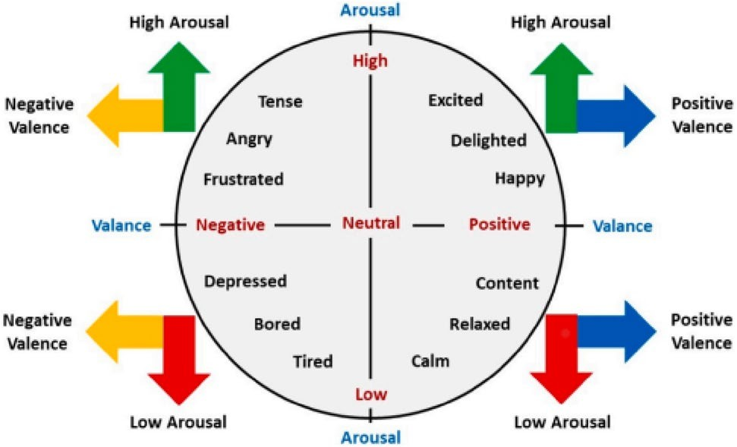
Fig. 1 Valence and Arousal Quadrants [67]

Further, an example of music emotion recognition is illustrated in Fig. 2 [11], which demonstrates the process of music emotion detection and the arousal-valence classification model. The process begins with the input of music, serving as the raw data source, followed by feature extraction techniques that extract relevant musical features such as pitch, rhythm, tempo, dynamics, and timbre. Once the features are extracted, the next step involves arousal classi- fication, where algorithms analyze the extracted features to determine the level of arousal associated with the music. This classification identifies whether the music shows emotions characterized by high physiological activation or low activation. Simultaneously, the valence classification process evaluates the emotional tone or quality of the music by analyzing the same features using algorithms which assess whether the music conveys positive or negative emotions. By integrating classification results of arousal and valence, the music emotion recognition system provides insights into the overall emotional impact of the music on listeners. Their approach emphasizes the use of the arousal-valence model not only for independent classification but also for learning and predicting a joint distribution of emotions, as joint modelling often yields more robust results. This flow highlights how advanced computational techniques can analyze music’s emotional content, contributing to domains such as music psychology, affective computing, and personalized music recommendation systems. Additionally, as noted in [11], there is currently no standardized music emotion dataset that combines emotional and physiological information. Therefore, exploring datasets that include both emotional and physiological data is crucial for advancing music emotion detection and classification. Hence, for understanding the concept of music emotion recognition, which includes detection and classification,
this work delves deeper into the intricacies of music emotion recognition, i.e., arousal-valence model, datasets, detection and classification approaches, issues and challenges in the upcoming sections which contributes to the continuation of the introduction section, where a deep understanding of how the music emotion analysis can be done is explained in detail.

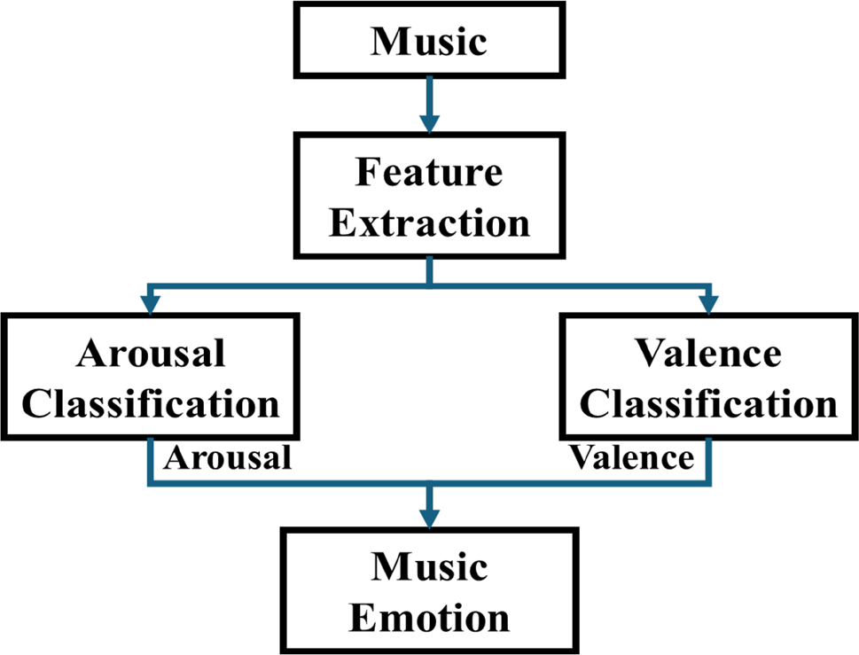
Fig. 2 Music Emotion Detec- tion [11]

Music emotion
This section explores a comprehensive overview encompassing the history, arousal-valence model, technological appli- cations, (i.e., ML, DL and other approaches), and the prevalent issues and challenges with music emotion detection and classification. This exploration aims to provide an understanding of how music influences emotions, tracing back the historical roots of music emotion research and development.

History

The history of music emotion detection and classification dates back to the 1990s when researchers began exploring the intersection of music, psychology, and technology [12]. Early efforts focused on developing computational models and algorithms capable of analyzing music’s emotional content. In the 1990s and early 2000s, research in this area primarily involved manual annotation of music datasets, where experts would label songs with emotional descriptors based on subjective interpretations [13]. These annotations served as training data for ML algorithms to learn patterns and cor- relations between musical features and emotions. As technology advanced, researchers started employing automated feature extraction techniques to capture music’s various acoustic and structural aspects, like tempo, rhythm, timbre, harmony, and melody [14, 15]. These features became crucial for building more sophisticated ML models and classifiers. Throughout the 2000s and into the 2010s, the field witnessed significant progress with the development of audio signal processing algorithms, pattern recognition techniques, and statistical models designed for music emotion analysis [16, 17]. Notably, earlier contributions such as the work by Han, Rho, Dannenberg, and Hwang (ISMIR 2009) [18] employed Support Vector Regression for emotion recognition within the arousal-valence framework, achieving promising results that laid the groundwork for subsequent advancements.
The rise of Big-Data and DL methodologies further has changed music emotion detection and classification [19]. DL algorithms, i.e., Convolutional-Neural-Networks (CNNs),2D-CNN,LSTM [10, 65] and Recurrent-Neural-Networks (RNNs) [20].A GNN with contrastive learning and GAN-based augmentation enhances EEG-based emotion recognition [64, 65], enabling detailed music feature analysis and improving prediction accuracy. Researchers also explored multimodal approaches by integrating audio features with textual data (such as lyrics) [21] and metadata (such as genre, artist, and mood tags) [22], a non-contact, client–server based multimodal emotion and behavior identification system to increase the effectiveness and precision of mental state evaluations[66] to improve emotion detection capabilities. By the mid- 2010s and continuing into the 2020s, music emotion detection and classification has become a vibrant research area with applications spanning music recommendation systems, affective computing, interactive music systems, and digital health technologies like music therapy [23]. The complete flow is presented in Fig. 3.
The evolution of this field showcases the interdisciplinary nature of music cognition, computational science, and psychological understanding, highlighting how technology continues to enhance our understanding of the emotional power of music.

Arousal‑valence model

The arousal-valence model in music is a fundamental framework used to understand and categorize the emotional responses caused by music [23]. The conceptual framework of this model revolves around two fundamental parameters: arousal, denoting the extent of physical stimulation or energy linked to an emotion, along with valence, signifying the degree of happiness or unhappiness experienced in relation to a particular emotion. The arousal parameter encompasses

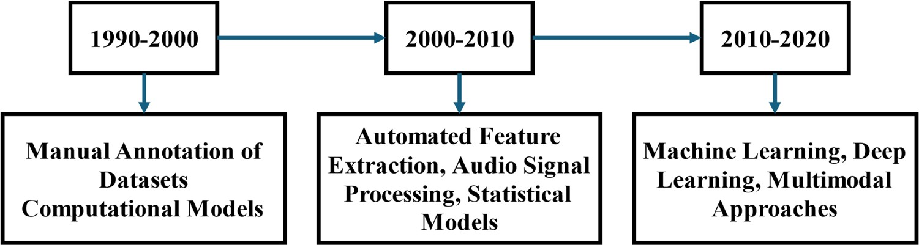
Fig. 3 The footprint of Music emotion detection and clas- sification models

a range that spans from high to low arousal, thereby denoting the degree or extent of excitement associated with a given emotion. Similarly, the valence parameter encompasses an arbitrary range that encompasses positive to negative valence, thereby demonstrating if the emotion within the question is perceived as good or bad. The arousal-valence model helps classify and analyze the emotional content of musical pieces by considering how different musical elements contribute to arousal and valence [24]. For example, fast tempos, loud dynamics, and complex rhythms tend to increase arousal levels, leading to emotions such as excitement, tension, or agitation. Similarly, slow tempos, soft dynamics, and consonant harmonies often evoke lower arousal levels, resulting in emotions like calmness, relaxation, or sadness. The valence dimension of the model reflects the emotional tone or quality of the music [25]. Musical features such as major or minor tonality, consonant or dissonant harmonies, and lyrical content influence whether the emotional experience is perceived as positive or negative [26]. For instance, music with uplifting melodies, harmonious progressions, and optimistic lyrics tends to evoke positive emotions like joy, hope, or love, representing high valence. On the other hand, music with dissonant chords, melancholic melodies, and dark lyrical themes may elicit negative emotions such as sadness, fear, or anger, reflecting low valence. The arousal-valence model has been widely utilized in music psychology, affective computing, and music therapy to analyze, classify, and predict emotional responses to music [27].

Technological advancements in recogniton of music emotion

The following section discusses key technological approaches presented for music emotion recognition, including machine learning, deep learning, and multimodal methods. The literature review was conducted by identifying peer- reviewed journal articles, conference papers, and other scholarly sources published in the last decade. Studies were selected based on their relevance to music emotion detection, methodology robustness, and empirical validation using publicly available datasets.

Machine learning and deep learning

Machine learning (ML) has emerged as a powerful tool for music emotion detection and classification, significantly improving the accuracy, efficiency, and scalability of music emotion analysis [28, 29]. Several ML and deep learning (DL) techniques, including convolutional neural networks (CNNs) [30], recurrent neural networks (RNNs) [31], and Deep- Belief Networks (DBNs) [32], have demonstrated notable success in learning meaningful patterns from large-scale music datasets. These models automatically extract features related to tempo, rhythm, pitch, dynamics, timbre, and spectral characteristics, facilitating emotion detection.
A key advantage of ML-based models is their ability to process extensive audio datasets, learn correlations between musical features and emotional labels, and generalize these patterns to predict emotions in new, unseen music samples [33]. CNNs, for instance, have been widely employed for feature extraction from spectrograms and mel-spectrograms, capturing both local and global patterns that contribute to emotional expression [ 34]. RNNs, on the other hand, are well-suited for modeling sequential dependencies in music, enabling them to capture melodic phrases, rhythmic pat- terns, and harmonic progressions that convey emotions [35].
Recent studies have explored multimodal approaches that integrate audio features with textual data (e.g., lyrics) [36], metadata (e.g., genre, artist, and mood tags) [37], and user-generated content (e.g., social media sentiment analysis) [38]. These multimodal techniques enhance the robustness of emotion detection by incorporating complementary informa- tion sources. The combination of multiple modalities allows for a more nuanced representation of the psychological impact of music, leading to improved prediction accuracy and contextual awareness.
Despite these advancements, challenges persist in ensuring the generalizability of ML-based emotion detection mod- els across different musical genres, cultures, and individual listener preferences. Further, while deep learning approaches have shown high accuracy, they often require large labeled datasets for effective training, which can be a limiting factor in real-world applications.

Other approaches

Beyond machine learning and deep learning, multimodal approaches have gained prominence in music emotion rec- ognition due to their ability to integrate diverse data sources. These methods leverage a combination of audio signals, textual content (lyrics) [36], metadata (genre, artist, mood tags) [37], and user-generated data (social media sentiment analysis) [38] to improve the accuracy and context-awareness of emotion detection models.

One of the key strengths of multimodal approaches is their ability to capture the intricate structure of emotional expression in music. For instance, audio features provide insights into tempo, melody, harmony, dynamics, and timbre, which contribute to the emotional impact of a piece. Textual data, such as lyrics, offer semantic and thematic cues that further contextualize the emotion conveyed by a song. Metadata, including genre and artist information, provides addi- tional contextual cues that can enhance emotion classification accuracy. Meanwhile, user-generated content, such as listener feedback and sentiment analysis, offers real-time insights into audience perceptions and emotional responses.
To effectively integrate these diverse modalities, researchers have explored different fusion strategies, including:

      - Early Fusion: Combining features from multiple modalities at the input level.
      - Late Fusion: Merging predictions from separate models trained on individual modalities.
      - Hybrid Fusion: Integrating features and predictions at multiple processing stages.

Recent studies have employed deep learning architectures such as multimodal neural networks, attention mecha- nisms, and specialized fusion layers to optimize multimodal feature integration. These techniques have been applied to various music emotion analysis tasks, including personalized music recommendation, affective computing, and interac- tive music experiences [39–42]. While multimodal approaches offer improved accuracy, they also introduce challenges related to data heterogeneity, computational complexity, and the need for extensive labeled datasets. Addressing these challenges requires the development of efficient fusion techniques and scalable learning models capable of handling diverse data sources.

Datasets

The selection of appropriate datasets is critical for evaluating the performance of music emotion recognition models. A variety of publicly available datasets have been developed to facilitate research in this field, each incorporating different annotation strategies, musical styles, and cultural contexts. The datasets referenced in this review were selected based on their widespread adoption in prior studies, availability of labeled emotional data, and diversity in musical content.

Issues and challenges

The field of music emotion detection and classification faces several challenges, primarily due to the subjective and dynamic nature of emotional responses to music. One of the key issues is that most existing work relies heavily on pre- annotated music datasets, where emotions are assigned based on consensus or subjective interpretations. However, music’s emotional impact can vary significantly from person to person, influenced by individual differences in musi- cal preferences, cultural background, past experiences, and current mood states. The inherent variation in emotional responses among different listeners poses a significant challenge in the development of universal approaches that can accurately represent and anticipate such responses to a given musical composition. Furthermore, the inherent complexity of human emotions poses a challenge in categorizing emotions into discrete labels or dimensions. Emotions are multi- faceted and context-dependent, often blending or evolving, making it difficult to create comprehensive and universally applicable emotion models for music.
In response to these challenges, recent research has explored alternative approaches, such as leveraging electroen- cephalography (EEG) signals, to acquire an improved understanding of a person’s emotional states in response to music. EEG signals measure electrical activity in the brain, providing insights into cognitive processes, emotional arousal, and affective responses. By recording EEG patterns in real time while participants listen to music, researchers can later ana- lyze neural correlates of emotional experiences, such as changes in attention, engagement, arousal, and valence. While real-time monitoring is possible, detailed analysis typically requires offline processing to filter out noise and average repeated recordings under the same stimulus to ensure reliability. Recent works utilizing EEG signals for music emotion detection have shown promising results in providing a more objective and personalized assessment of emotional states. These approaches offer a direct window into the neural mechanisms underlying emotional responses, bypassing the limitations of self-reporting or external annotations. By identifying neural signatures associated with specific emotions or affective states, EEG-based models can enhance the accuracy, granularity, and individualized nature of music emo- tion detection and classification. Moreover, EEG-based approaches enable real-time monitoring of emotional dynamics during music listening, capturing temporal fluctuations, transitions between emotional states, and individual variability. This dynamic and continuous assessment of emotional responses offers a comprehensive understanding of how music

influences emotions over time. Moreover, a limitation of EEG-based studies is the susceptibility of EEG signals to noise, requiring repeated recordings and extensive post-processing to isolate neural responses to music. This dependency on offline processing challenges the feasibility of immediate emotional feedback, which can be a limitation in applica- tions like real-time music therapy or adaptive music systems. For music therapy, this limitation means that while EEG can provide valuable insights into neural responses to music, its current practical use may be constrained to research settings rather than real-time therapeutic applications. Future advancements in EEG technology and real-time signal processing algorithms as discussed in the next section have overcome these challenges, making EEG a more viable tool for interactive therapeutic interventions. Some of the existing approaches presented for music emotion recognition are discussed in the next section.

Novel music emotion recognition approaches, dataset, and current gap
In this section, the different music emotion approaches using the EEG signal are discussed. An example of how the music emotion can help in music therapy is presented in Fig. 4. The process comprised two main models: The MER model for recognizing EEG signals and the MEC model for identifying music signals. Analysis of the effectiveness of music therapy can be achieved by fusing the EEG emotional states with the different emotion types found in music [43]. In the next section the different approaches are discussed.

Approaches

EEG-based emotion detection provides precise brain responses but requires invasive equipment. Non-EEG methods (facial analysis, speech, ECG, GSR) are more convenient but less accurate and prone to interference. EEG offers deeper insights, while non-EEG prioritizes usability. Zhou et al. [43] proposed a musical treatment approach that incorpo- rates semantic matching between audio features and EEG-derived emotional states. This approach aimed to align the emotional content of music with the neural emotional responses of listeners, thereby enhancing the accuracy of emotional assessments. The study demonstrated that semantic matching between musical features and EEG signals significantly improved emotion classification. Moreover, Zhou et al. developed an EEG-based Emotion-Recognition (EER) approach using 32 EEG channels to detect 20 different emotions, achieving a mean accuracy of over 80% and 90% for emotion detection datasets (DEAP dataset, DREAMER dataset and a dataset involving emotional responses to music). Moreover, utilizing nine different combinations of musical features, their proposed Music-based Emotion- Classification (MEC) approach achieved an average classification accuracy of over 90% across eight commonly rec- ognized musical emotion categories. These results highlight the effectiveness of integrating both audio and EEG data for emotional assessment. Additionally, they explored the semantic relationship between musical styles and psychological shifts. The findings revealed that happy music videos could transform feelings of trust, mania, disgust, and fear into feelings of surprise or closeness, whereas dark music videos might transform feelings of intimacy into fear. Further, the overall music emotion approach using EEG signals, as depicted in Fig. 5 [44], begins by consider- ing both music and EEG signal data. Initially, valence and arousal values are evaluated from the music dataset, and corresponding emotion labels are assigned based on these evaluations. Subsequently, features are extracted from the music data, and a calculation model or technique (often using machine learning models) is applied to derive emotions from these features. EEG signals, which capture neural activity associated with emotional responses, are

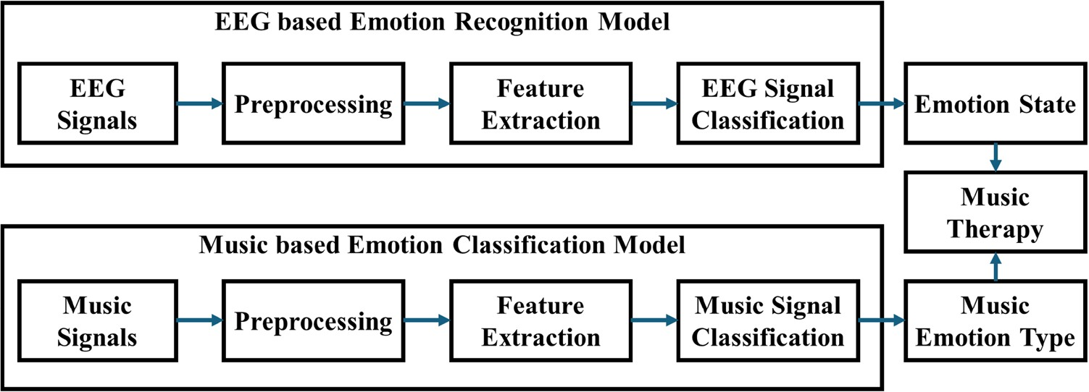
Fig. 4 Music Emotion Clas- sification using EEG [43]

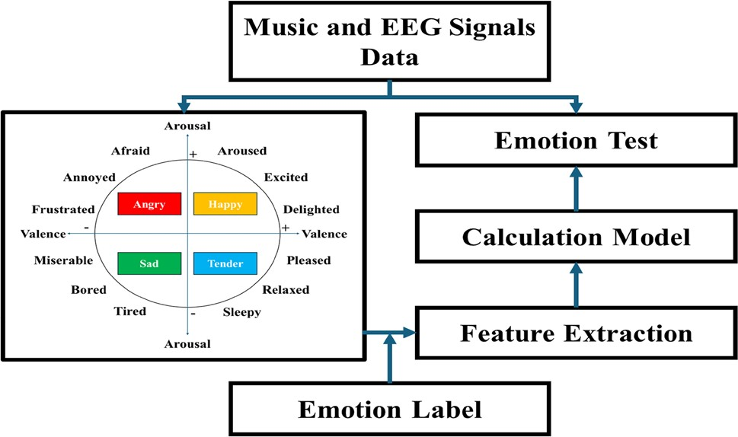
Fig. 5 Music emotion testing [43]

then used as a complementary source of information to infer emotions. Integrating music features and EEG signals enables a more comprehensive understanding of music-induced emotions, offering better accuracy and depth in music emotion analysis.
Zhou and Lian [44] introduced a transformer-based approach for emotion recognition using multi-channel EEG data. Their method avoids the local responsive range problems inherent in CNNs by directly feeding unprocessed EEG input into the transformer. EEG recordings were taken from 20 participants while they listened to music. The proposed method achieved an accuracy of 97.1% in tripartite emotion classification (neutral, negative, positive) and 97.3% for binary classification (negative vs. positive). These impressive results demonstrate the efficacy of transformer-based models in handling EEG emotion recognition tasks. Building on the challenge of accurately identifying emotional states from EEG,
[45] developed a novel DL-based emotion detection technique. They proposed an EEG-based emotion identification method that analyzed brain electrochemical wave patterns to detect emotional states such as relaxed, sad, angry, and happy in response to different musical compositions. Participants listened to music from various genres in a controlled environment, and spectrograms were extracted from the EEG data across multiple channels. Transfer learning (TL) was applied using pre-trained deep network models (AlexNet and VGG16) to process the EEG data. Among these models, VGG16 yielded the best classification results, further validating the use of transfer learning in EEG emotion detection.
To quantify the range of emotions generated by an entirely novel musical composition for individual listeners, [46] integrated Thayer’s psychology approach with an improved brain-emotional learning (BEL) framework. Their method considered 12 emotional components, which corresponded to four distinct regions of the brain responsible for emotional processing. Using Thayer’s psychology approach and fuzzy logic rules, they fine-tuned the input data. The DREAMER data- set was used to evaluate the approach, which outperformed both a multi-layer network and the initial BEL framework. The method achieved a mean accuracy of 69% for arousal and 36% for valence, showing promising results in the emo- tion recognition field. In [47] suggested an approach based on Fourier–Bessel-Series Expansion and Empirical-Wavelet- Transform (FBSE-EWT) to calculate Shannon spectrum and K-nearest neighbor (K-NN) entropy for emotion detection. Their Multi-Varied Hilbert Marginal Spectrum (MHMS) method was used to analyze the multi-channel EEG data, and the model achieved a classification accuracy of 94.4% when applied to the SEED dataset. This technique outperformed prior methods in both accuracy and robustness, providing strong evidence of the utility of entropy-based feature extraction methods in EEG emotion classification.
In addressing the challenge of EEG emotion detection, [48] proposed the Multi-Source Marginal-Distribution-Adapta- tion (MS-MDA) method. This approach focuses on adapting domain-specific and domain-invariant information to improve classification performance. The method was evaluated using the SEED and SEED-IV datasets for three- and four-emotion recognition tasks. In cross-subject and cross-session evaluations, MS-MDA outperformed several state-of-the-art meth- ods, demonstrating its strength in handling domain shifts. In [49], used the FBSE-EWT technique in combination with machine learning (ML) methods to enhance cross-subject emotion detection. This approach achieved robust performance by extracting entropy and energy features from EEG signals. It outperformed other methods, demonstrating the utility of FBSE-EWT and various ML techniques, including KNN and Artificial Neural Networks (ANN), in EEG-based emotion recognition. In [50], proposed a semi-supervised framework called PARSE (Pairwise-Alignment of Representations for Semi-Supervised EEG) to address the abundance mismatch between labeled and unlabeled data. Their approach was tested on four publicly available EEG datasets—SEED-V, SEED-IV, SEED, and AMIGOS—and outperformed state-of-the-art methods, particularly in the AMIGOS (valence) and SEED-IV datasets. The results showed that PARSE significantly improves performance in semi-supervised emotion detection by effectively aligning representations.

In [51], introduced the Variational-Instance-Adaptive-Graph (V-IAG) method for emotion detection, which models the uncertainty in EEG data while capturing the relationships between different EEG channels. This method demonstrated improved performance over several existing systems when tested on DREAMER, SEED, and MPED datasets. In [52], sug- gested using Prototypical-Representation-based Pairwise-Learning (PR-PL) to improve transfer learning in EEG emotion recognition. The method demonstrated improved robustness against noisy labels and outperformed existing methods in cross-validation tests on the SEED-IV and SEED datasets, with a mean improvement of 2.58% and 2.04%, respectively. In [53], proposed Multi-Source Transfer-Learning (MSTL) to enhance emotion recognition accuracy by reducing data drift across domains. They tested their method on SEED and DEAP datasets, achieving an accuracy of 86.59% on SEED and 64.40% on DEAP, outperforming existing domain adaptation techniques [54]. Finally, [55] introduced a semi-super- vised ML framework called MGFKD (Multi-Domain Geodesic-Flow Kernel-Dynamic-Distribution-Alignment), which uses a small number of labeled samples for domain adaptation. The approach showed superior performance compared to semi-supervised and unsupervised methods, achieving accuracy improvements of up to 90.20% on SEED and 69.99% on SEED-IV datasets.

Datasets

In this section, a selection of publicly available EEG datasets utilized for emotion recognition, particularly in relation to the methods discussed in Sect. 3.1, are presented. These datasets are integral to advancing research in emotion detection using EEG signals and is presented in Table 1. The following datasets were referenced in the reviewed methodologies:

- DREAMER [56]: The DREAMER dataset includes EEG signals from 23 subjects who self-reported their emotional con- dition following every stimulation in the categories of arousal, dominance, and valence. Arousal, dominance, and valence were the outcomes of classification.
- SEED [57]: SEED was built using records of three procedures that were replayed for fifteen subjects, with fifteen sam- ples made up per session. EEG recordings throughout emotion-inducing video clips were the basis for the research setting. Neutral, negative, and positive emotions were the classes within the SEED dataset.
- SEED IV [58, 59]: Fifteen individual’s EEGs from three sessions, each with twenty-four tests, made up SEED IV. As part of one experiment, participants wore electrodes on their brains to record their EEG while watching videos designed to evoke a range of emotions. This dataset took into account four different emotion categories: fear, sad, happy, and neutral.
- SEED V [60]: An improvement based on the SEED-IV dataset was initially created as SEED-V. There were five types of emotions: sad, happy, disgust, neutral, and fear. The range of classifications of emotions was increased. Within the SEED-V dataset, not only did they provide EEG signals, but they also included eye movement parameters collected using Senso-Motoric Instruments (SMI) eye-tracking glasses. This made the dataset an excellent example for multi- modal dataset towards recognizing emotions.
- AMIGOS [61]: A database with the purpose of doing studies on impact, personality characteristics, and moods through the utilization of neuro-physiological information was presented. The data-set enabled a multi-modal investigation

Table 1 Dataset used in different studies

Method, Reference, Year Methodology Dataset

BEL, [46], 2023 Brain-Emotional-Learning DREAMER

MFBSE-EWT + ARF, [47], 2021 Fourier–Bessel-Series-Expansion based Empirical-Wavelet-Trans-
form + Shannon + KNN
SEED, DREAMER

MS-MDA, [48], 2021 Multi-source Marginal-Distribution-Adaptation SEED, SEED-IV

FBSE-EWT + NCA, [49], 2022 Fourier–Bessel-Series-Expansion based-Empirical-Wavelet-Transform
and NCA-Feature-Selection Method
SEED, DEAP

PARSE, [50], 2022 Pairwise-Alignment of Representations + Semi-Supervised SEED, SEED-IV, SEED-V, AMIGOS V-IAG, [51], 2023 Variational-Instance-Adaptive-Graph SEED, DREAMER, MPED

PR-PL, [52], 2023 Transfer-Learning + Prototypical-Representation based Pairwise-
Learning
SEED, SEED-IV

MSTL, [53], 2023 Multi-Source Transfer-Learning SEED, DEAP MGFKD [55], 2024 Multi-domain Geodesic-Flow-Kernel Dynamic-Distribution-Alignment SEED, SEED-IV

of individual’s emotional reactions in connection with their moods and character, along with an examination of the effects of (i) group/individual setup and (ii) video length (short vs. lengthy). Two types of experiments were used to get the information. With the use of sensor devices, the subject’s signals, including EEG, electrocardiogram (ECG), and Galvanic-Skin-Response (GSR), were captured in various indoor and outdoor situations.
- DEAP [62]: DEAP is a multi-modal dataset that included observations of 32 subjects EEGs, electromyograms (EMGs), and electrooculograms (EOGs). To create the data collection, subjects were prompted to watch the clip and rate how they felt on three parameters: arousal (ranging from very excited to very uninterested), valence (from nice to bad), and dominance (the degree to which they could control their emotions, which ranged from very weak to very strong).
- MPED [63]: MPED included observations of various physiologic signals (EEG, ECG, GSR) from a subject group of thirty individuals. These observations were captured when the video clips were shown to the subject group. Anger, joy, fear, disgust, neutral, and sad were the 7 classifications into which the suggested emotions in the clips belonged.

Current gap in music emotion detection and classification using EEG signals

The application of EEG signals for music emotion detection has seen substantial growth, yet several challenges remain in making these systems robust, generalizable, and interpretable. Addressing these gaps is essential for advancing the field and making EEG-based emotion detection more effective in practical, real-world contexts. Here, we present a more detailed exploration of these gaps, followed by some technical considerations for overcoming them:

- Generalization Across Diverse Populations and Contexts: Many current studies on EEG-based emotion recognition are limited by their focus on specific populations or small, homogenous samples. To bridge this gap, future research needs to emphasize models that generalize across a wide range of individuals, including diverse age groups, cultural backgrounds, and neurological conditions.
- Technical direction:
  - Cross-population training datasets: It will be critical to develop or aggregate larger, more diverse EEG datasets to train models that can handle variability in neural responses. For instance, datasets like DEAP and AMIGOS, which include physiological data from different subjects, should be expanded to include greater diversity in the demographic profiles.
  - Transfer learning: Transfer learning techniques could be explored, where models trained on one population are fine-tuned with smaller, targeted datasets from new populations. This approach could help overcome the chal- lenge of limited training data for underrepresented groups.

- Granularity in Emotion Recognition: Current models primarily focus on detecting broad emotional categories (e.g., happy, sad, relaxed), but there is a need for more nuanced classification, which can recognize subtle emotional shifts or specific emotional dimensions such as nostalgia, surprise, or mixed emotions. This granularity is particularly rel- evant when analyzing emotions evoked by music, which is a highly personal and dynamic stimulus.
- Technical direction:
  - Multidimensional emotion models: Instead of discrete categories, future models could utilize continuous or multi- dimensional emotion spaces (e.g., arousal, valence, and dominance as in the DEAP dataset), or explore higher- order emotions. This could allow for finer distinctions between emotions, which is essential for understanding complex emotional experiences with music.
  - Temporal and context-aware models: Music evokes emotional responses that change over time. Recurrent neural networks (RNNs) or Long Short-Term Memory (LSTM) networks, which can capture temporal dynamics in the data, should be more extensively explored to track emotional shifts throughout music listening.

- Music Stimulus-Dependent Sensitivity: Many existing emotion detection models are sensitive to the specific charac- teristics of the music used in the study, such as genre, tempo, or musical features. This makes it difficult to generalize models across different types of music and real-world listening scenarios.
- Technical direction:

  - Cross-genre and cross-tempo models: Future research could focus on the development of music-agnostic models that generalize across different genres, tempos, and other musical features. This could be achieved by employing multi-modal approaches that integrate audio features (e.g., tempo, pitch, rhythm) along with EEG signals.
  - Deep learning models for music features: Using deep neural networks (DNNs) to extract complex musical features in conjunction with EEG signals could help build models that are less sensitive to the specific characteristics of the music. For example, convolutional neural networks (CNNs) could be used to extract hierarchical music features from raw audio, which can then be correlated with EEG data to detect emotional states.

- Interpretability and Explainability: As EEG-based emotion detection is increasingly used in clinical and therapeutic settings (e.g., music therapy), there is a pressing need to improve the interpretability of these models. Clinicians and researchers need transparent models that can provide actionable insights into the neural mechanisms behind music-induced emotions.
- Technical direction:
  - Explainable AI (XAI): Developing techniques for explainable AI (XAI) in EEG-based emotion recognition systems will be crucial. Methods like attention-based mechanisms or saliency maps can help highlight which areas of the brain or specific EEG features are most indicative of emotional states.
  - Neurofeedback systems: Another potential direction could be integrating EEG-based emotion detection with neurofeedback techniques, where patients are given real-time feedback about their emotional states. Such sys- tems could be beneficial in therapeutic settings, especially for conditions like depression or anxiety.

By addressing these gaps through targeted technical advancements, future EEG-based emotion recognition systems can become more adaptable, precise, and meaningful, contributing to practical applications in areas such as personal- ized music therapy, emotion-aware computing, and interactive entertainment. (Table 2)

Comparative study of music emotion recognition approaches

In this section, we present a comparative analysis of the major methodologies used for Music Emotion Recognition (MER), particularly focusing on Machine Learning (ML), Deep Learning (DL), Multimodal Approaches, and EEG-based methods. While each approach has contributed significantly to the field, they vary in effectiveness depending on factors such as data modality, computational complexity, interpretability, and real-time applicability.
Key Findings and Observations.

- Deep learning models (CNNs, RNNs) have achieved high accuracy due to their ability to automatically learn hierarchi- cal feature representations. However, they require large labeled datasets and high computational power.
- Multimodal approaches have enhanced music emotion recognition by incorporating multiple sources of information, such as lyrics, metadata, and social media sentiment, improving context-awareness and reliability.
- EEG-based methods provide a direct physiological measure of emotional response, making them highly accurate for personalized emotion detection. However, their practicality is limited due to noise susceptibility and the need for extensive post-processing.

Conclusion and future directions
In this paper, we reviewed the current state of music emotion detection using EEG signals, exploring the evolution of the field, its methodologies, and the challenges it faces. As the field advances, it is evident that addressing key research gaps is crucial for developing more reliable, versatile, and interpretable EEG-based emotion recognition systems. We identified several critical areas for future research, focusing on overcoming limitations related to population diversity, emotion granularity, music stimulus dependency, and model explainability. One key direction is the integration of multimodal data, such as combining EEG signals with heart rate (ECG), eye tracking, and facial expressions, as seen in the SEED V dataset. This integration could help improve emotion detection by synchronizing various physiological signals to create

Table 2 Comparison of methodologies
Approach
Traditional ML (SVM, RF, KNN)
Feature Extraction
Handcrafted audio features (e.g., MFCC, spectral features, tempo)
Advantages
Computationally efficient, inter- pretable
Limitations
Feature engineering required, limited ability to model complex patterns
Requires large labeled datasets, high computational cost
Applications
Basic music classification, playlist generation
Deep Learning (CNN, RNN, DBN)
Automated feature learning from spectrograms, mel-spectrograms
High accuracy, ability to model temporal and spatial dependen- cies
Context-aware, improved accuracy
Advanced music classification, affec- tive computing, real-time music recommendations
Personalized music recommenda- tions, sentiment-aware applica- tions
Music therapy, brain-computer interfaces (BCI)
Multimodal (Audio + Lyrics + Meta- data)
Feature fusion (audio, text, meta- data)
Data heterogeneity, requires com- plex fusion techniques
EEG-based Approaches
EEG signals + music features
Captures real-time emotional responses, objective emotion assessment
Noise sensitivity, requires special- ized hardware, offline processing

more robust emotion recognition systems. Another important direction is the development of real-time emotion detec- tion systems, particularly for therapeutic contexts, where immediate feedback could enhance music therapy by tailoring it to the patient’s current emotional state. Additionally, the field of affective computing in human–computer interaction (HCI) can benefit from EEG-based emotion detection systems, which could help create more empathetic and responsive machines. Research into integrating these systems with interactive technologies, such as music players, video games, or virtual assistants, will enhance user experiences. In clinical settings, EEG-based emotion detection could offer innovative applications for treating conditions like depression, anxiety, or PTSD, particularly when combined with real-time tracking in music therapy. Moreover, advancements in neurofeedback could enable personalized, actionable insights for users. Finally, as music holds significant cultural value, understanding how different cultures emotionally respond to music is vital. Future research should aim to identify universal emotional patterns and culture-specific responses, supporting the development of cross-cultural emotion detection systems. In conclusion, addressing these research gaps and pursuing the proposed future directions will propel EEG-based music emotion detection towards more accurate, adaptable, and practical applications, ultimately revolutionizing fields such as personalized music therapy, affective computing, and HCI.

Author contribution Sheetal: Has worked on paper preparation. R.S. Patil Has initiated the idea and helped further. R.H.Goudar has giving many research insight for the work. Sangeeta: suggested some data set and gave some input to survey. Shewta: Helped in concluding the topic and coming up with a paper.

Funding Open access funding provided by Manipal Academy of Higher Education, Manipal. This paper does not have any Funding Support from any Agency.

Data Availability No datasets were generated or analysed during the current study.

Declarations
Ethics approval and consent to participate Human Ethics and Consent to Participate declaration is not applicable.

Consent for publication Consent to Publish declaration is not applicable.

Conflict of interest The authors declare no competing interests.

Open Access This article is licensed under a Creative Commons Attribution 4.0 International License, which permits use, sharing, adapta- tion, distribution and reproduction in any medium or format, as long as you give appropriate credit to the original author(s) and the source, provide a link to the Creative Commons licence, and indicate if changes were made. The images or other third party material in this article are included in the article’s Creative Commons licence, unless indicated otherwise in a credit line to the material. If material is not included in the article’s Creative Commons licence and your intended use is not permitted by statutory regulation or exceeds the permitted use, you will need to obtain permission directly from the copyright holder. To view a copy of this licence, visit http://creativecommons.org/licenses/by/4.0/.

References
- Hesmondhalgh D. streaming’s effects on music culture: old anxieties and new simplifications. Cult Sociol. 2021;16(1):3–24. https://doi. org/10.1177/17499755211019974.
- Darvish M, Bick M. The role of digital technologies in the music industry—a qualitative trend analysis. Inf Syst Manag. 2023;41(2):181–200. https://doi.org/10.1080/10580530.2023.2225129.
- Rebecchini L. Music, mental health, and immunity, Brain, Behavior, & Immunity. Health. 2021;18(100374): 100374. https://doi.org/10. 1016/j.bbih.2021.100374.
- Sayali Bhandarkar BV. Salvi, and Pravin Shende, “current scenario and potential of music therapy in the management of diseases.” Behav Brain Res. 2024;458:114750–114750. https://doi.org/10.1016/j.bbr.2023.114750.
- Adiasto K, Beckers DGJ, van Hooff MLM, Roelofs K, Geurts SAE. Music listening and stress recovery in healthy individuals: a systematic review with meta-analysis of experimental studies. PLoS ONE. 2022;17(6): e0270031. https://doi.org/10.1371/journal.pone.0270031.
- de Witte M, da Silva A, Pinho G-JS, Moonen X, Bos AER, van Hooren S. Music therapy for stress reduction: a systematic review and meta- analysis. Health Psychol Rev. 2020;16(1):134–59. https://doi.org/10.1080/17437199.2020.1846580.
- Feneberg AC, et al. Perceptions of stress and mood associated with listening to music in daily life during the COVID-19 lockdown. JAMA Netw Open. 2023;6(1): e2250382. https://doi.org/10.1001/jamanetworkopen.2022.50382.

- Grimaud AM, Eerola T. Emotional expression through musical cues: A comparison of production and perception approaches. PLoS ONE. 2022;17(12):e0279605. https://doi.org/10.1371/journal.pone.0279605.
- Thayer RE. The Biopsychology of Mood and Arousal. Oxford University; 1990. https://doi.org/10.1093/oso/9780195068276.001.0001.
- Han X, Chen F, Ban J. Music emotion recognition based on a neural network with an inception-gru residual structure. Electronics. 2023;12(4):978. https://doi.org/10.3390/electronics12040978.
- Nguyen VL, Kim D, Ho PV, Lim Y. A new recognition method for visualizing music emotion. Int J Electrical Comput Eng (IJECE). 2017;7(3):1246. https://doi.org/10.11591/ijece.v7i3.pp1246-1254.
- Hodges DA. Music psychology and music education: what’s the connection? Res Stud Music Educ. 2003;21(1):31–44. https://doi.org/10. 1177/1321103x030210010301.
- Lesaffre M, Leman M, Bernard De Baets, and J-P Martens (2004) Methodological considerations concerning manual annotation of musical audio in function of algorithm development,” ISMIR 2004, 5th International Conference on Music Information Retrieval, Barcelona, Spain, October 10–14, 2004, Proceedings, pp. 64–71.
- Zhang J. Music feature extraction and classification algorithm based on deep learning. Sci Program. 2021;2021:1–9. https://doi.org/10. 1155/2021/1651560.
- Panda R, Rocha B, Paiva RP. Music emotion recognition with standard and melodic audio features. Appl Artif Intell. 2015;29(4):313–34. https://doi.org/10.1080/08839514.2015.1016389.
- Na W, Yong F. Music recognition and classification algorithm considering audio emotion. Sci Program. 2022;2022: e3138851. https://doi. org/10.1155/2022/3138851.
- Xia Y, Xu F. Study on music emotion recognition based on the machine learning model clustering algorithm. Math Probl Eng. 2022;2022: e9256586. https://doi.org/10.1155/2022/9256586.
- Han BJ, Rho S, Dannenberg RB, and Hwang E (2009) SMERS: Music emotion recognition using support vector regression,” Proceedings of the 10th International Society for Music Information Retrieval Conference, ISMIR 2009, Kobe International Conference Center, Kobe, Japan, October 26–30, pp. 651–656.
- Qiao Y, Jiajia M, Xie J, Binghui H, Liu G. Music emotion recognition based on temporal convolutional attention network using EEG. Front Human Neurosci. 2024. https://doi.org/10.3389/fnhum.2024.1324897.
- Tong G. Multimodal music emotion recognition method based on the combination of knowledge distillation and transfer learning. Sci Program. 2022;2022:1–13. https://doi.org/10.1155/2022/2802573.
- Hu X, Li F, Liu R. Detecting music-induced emotion based on acoustic analysis and physiological sensing: a multimodal approach. Appl Sci. 2022;12(18):9354. https://doi.org/10.3390/app12189354.
- Metilda Florence S, Uma M. Emotional detection and music recommendation system based on user facial expression. IOP Conf Ser: Mater Sci Eng. 2020;912(6):062007. https://doi.org/10.1088/1757-899X/912/6/062007.
- Ho HY, Loo FY. A theoretical paradigm proposal of music arousal and emotional valence interrelations with tempo, preference, familiarity, and presence of lyrics. New Ideas Psychol. 2023;71:101033. https://doi.org/10.1016/j.newideapsych.2023.101033.
- Hofbauer LM, Rodriguez FS. Emotional valence perception in music and subjective arousal: experimental validation of stimuli. Int J Psychol. 2023;58(5):465–75. https://doi.org/10.1002/ijop.12922.
- Lee W, Son G. Investigation of human state classification via EEG signals elicited by emotional audio-visual stimulation. Multimed Tools Appl. 2023. https://doi.org/10.1007/s11042-023-16294-w.
- Treider JM, Kunst JR, Vuoskoski JK. The influence of musical parameters and subjective musical ratings on perceptions of culture. Sci Rep. 2023;13(1):20682. https://doi.org/10.1038/s41598-023-45805-w.
- Martín JC, Ortega-Sánchez D, Miguel IN, Martín GMG. Music as a factor associated with emotional self-regulation: A study on its relationship to age during COVID-19 lockdown in Spain. Heliyon. 2021;7(2):e06274. https://doi.org/10.1016/j.heliyon.2021.e06274.
- Lucia-Mulas MJ, Revuelta-Sanz P, Ruiz-Mezcua B, Gonzalez-Carrasco I. Automatic music emotion classification model for movie soundtrack subtitling based on neuroscientific premises. Appl Intell. 2023;53(22):27096–109. https://doi.org/10.1007/ s10489-023-04967-w.
- Hizlisoy S, Yildirim S, Tufekci Z. Music emotion recognition using convolutional long short term memory deep neural networks. Eng Sci Technol, Int J. 2021;24(3):760–7. https://doi.org/10.1016/j.jestch.2020.10.009.
- Grekow J. Music emotion recognition using recurrent neural networks and pretrained models. J Intell Inf Syst. 2021. https://doi.org/10. 1007/s10844-021-00658-5.
- Tong G. Music emotion classification method using improved deep belief network. Mob Inf Syst. 2022;2022:1–7. https://doi.org/10.1155/ 2022/2715765.
- Jia X. A music emotion classification model based on the improved convolutional neural network. Comput Intell Neurosci. 2022;2022:1–11. https://doi.org/10.1155/2022/6749622.
- Yang J. A novel music emotion recognition model using neural network technology. Front Psychol. 2021. https://doi.org/10.3389/fpsyg. 2021.760060.
- Kritsis K, Kylafi T, Kaliakatsos-Papakostas M, Pikrakis A, Katsouros V. On the adaptability of recurrent neural networks for real-time jazz improvisation accompaniment. Front Artif Intell. 2021. https://doi.org/10.3389/frai.2020.508727.
- Chen C, Li Q. A multimodal music emotion classification method based on multifeature combined network classifier. Math Probl Eng. 2020;2020:1–11. https://doi.org/10.1155/2020/4606027.
- Barthet M, Fazekas G, Sandler M. Music Emotion Recognition: From Content- to Context-Based Models. In: Aramaki M, Barthet M, Kronland- Martinet R, Ystad S, editors. From Sounds to Music and Emotions. Berlin: Springer; 2013. p. 228–52. https://doi.org/10.1007/978-3-642- 41248-6_13.
- He N, Ferguson S. Music emotion recognition based on segment-level two-stage learning. Int J Multimed Inf Retrieval. 2022;11(3):383–94. https://doi.org/10.1007/s13735-022-00230-z.
- Mocanu B, Tapu R, Zaharia T. Multimodal emotion recognition using cross modal audio-video fusion with attention and deep metric learning. Image Vis Comput. 2023;133: 104676. https://doi.org/10.1016/j.imavis.2023.104676.

- Zeng F. Multimodal music emotion recognition method based on multi data fusion. Int j Arts Technol. 2023;14(4):271–82. https://doi.org/ 10.1504/ijart.2023.133662.
- Yu Z. Research on multimodal music emotion recognition method based on image sequence. Sci Program. 2021;2021:1–10. https://doi. org/10.1155/2021/7087588.
- Kang J and Herremans D (2024) Are we there yet? A brief survey of Music Emotion Prediction Datasets, Models and Outstanding Chal- lenges,” arXiv (Cornell University), https://doi.org/10.48550/arxiv.2406.08809.
- Zhou TH, Liang W, Liu H, Wang L, Ryu KH, Nam KW. EEG emotion recognition applied to the effect analysis of music on emotion changes in psychological healthcare. Int J Environ Res Public Health. 2023;20(1):378. https://doi.org/10.3390/ijerph20010378.
- Cui X, Yongrong W, Jipeng W, You Z, Xiahou J, Ouyang M. A review: music-emotion recognition and analysis based on EEG signals. Front Neuroinf. 2022. https://doi.org/10.3389/fninf.2022.997282.
- Zhou Y, Lian J. Identification of emotions evoked by music via spatial-temporal transformer in multi-channel EEG signals. Front Neurosci. 2023. https://doi.org/10.3389/fnins.2023.1188696.
- Er MB, Çiğ H, Aydilek İB. A new approach to recognition of human emotions using brain signals and music stimuli. Appl Acoust. 2021;175: 107840. https://doi.org/10.1016/j.apacoust.2020.107840.
- Jandaghian M, Setayeshi S, Razzazi F, Sharifi A. Music emotion recognition based on a modified brain emotional learning model. Multimed Tools Appl. 2023;82(17):26037–61. https://doi.org/10.1007/s11042-023-14345-w.
- Bhattacharyya A, Tripathy RK, Garg L, Pachori RB. A novel multivariate-multiscale approach for computing EEG spectral and temporal complexity for human emotion recognition. IEEE Sens J. 2021;21(3):3579–91. https://doi.org/10.1109/JSEN.2020.3027181.
- Chen H, Jin M, Li Z, Fan C, Li J, He H. MS-MDA: multisource marginal distribution adaptation for cross-subject and cross-session EEG emo- tion recognition. Front Neurosci. 2021. https://doi.org/10.3389/fnins.2021.778488.
- Anuragi A, Sisodia DS, Pachori RB. EEG-based cross-subject emotion recognition using Fourier-Bessel series expansion based empirical wavelet transform and NCA feature selection method. Inf Sci. 2022;610:508–24. https://doi.org/10.1016/j.ins.2022.07.121.
- Zhang G, Davoodnia V, Etemad A. PARSE: pairwise alignment of representations in semi-supervised EEG learning for emotion recognition. IEEE Trans Affective Comput. 2022;13(4):2185–200. https://doi.org/10.1109/TAFFC.2022.3210441.
- Song T, Liu S, Zheng W, Zong Y, Cui Z, Li Y, Zhou X. Variational instance-adaptive graph for EEG emotion recognition. IEEE Trans Affective Comput. 2023;14(1):343–56. https://doi.org/10.1109/TAFFC.2021.3064940.
- Zhou R, Zhang Z, Hong F, Zhang L, Li L, Huang G, Li F, Yang X, Dong Y, Zhang Y-T, Liang Z. PR-PL: a novel prototypical representation based pairwise learning framework for emotion recognition using EEG signals. IEEE Trans Affective Comput. 2024;15(2):657–70. https://doi.org/ 10.1109/TAFFC.2023.3288118.
- She Q, Shi X, Fang F, Ma Y, Zhang Y. Cross-subject EEG emotion recognition using multi-source domain manifold feature selection. Comput Biol Med. 2023;159:106860–106860. https://doi.org/10.1016/j.compbiomed.2023.106860.
- Wang J, Feng W, Chen Y, Yu H, Huang M and Yu P. S (2018) “Visual Domain Adaptation with Manifold Embedded Distribution Alignment,” arXiv (Cornell University), https://doi.org/10.48550/arxiv.1807.07258.
- Zhang R, Guo H, Zongxin X, Yuxia H, Chen M, Zhang L. MGFKD: a semi-supervised multi-source domain adaptation algorithm for cross- subject EEG emotion recognition. Brain Res Bull. 2024;208:110901. https://doi.org/10.1016/j.brainresbull.2024.110901.
- Katsigiannis S, Ramzan N. DREAMER: a database for emotion recognition through EEG and ECG signals from wireless low-cost off-the- shelf devices. IEEE J Biomed Health Inform. 2018;22(1):98–107. https://doi.org/10.1109/jbhi.2017.2688239.
- Zheng W-L, Lu B-L. Investigating critical frequency bands and channels for EEG-based emotion recognition with deep neural networks. IEEE Trans Auton Ment Dev. 2015;7(3):162–75. https://doi.org/10.1109/TAMD.2015.2431497.
- Zheng W-L, Zhu J-Y, Bao-Liang L. Identifying stable patterns over time for emotion recognition from EEG. IEEE Trans Affective Comput. 2019;10(3):417–29. https://doi.org/10.1109/TAFFC.2017.2712143.
- Zheng W-L, Liu W, Lu Y, Lu B-L, Cichocki A. EmotionMeter: a multimodal framework for recognizing human emotions. IEEE Trans Cybern. 2019;49(3):1110–22. https://doi.org/10.1109/TCYB.2018.2797176.
- Liu W, Qiu J-L, Zheng W-L, Lu B-L. Comparing recognition performance and robustness of multimodal deep learning models for multi- modal emotion recognition. IEEE Trans Cognitive Dev Syst. 2022;14(2):715–29. https://doi.org/10.1109/TCDS.2021.3071170.
- Miranda-Correa JA, Abadi MK, Sebe N, Patras I. AMIGOS: a dataset for affect, personality and mood research on individuals and groups. IEEE Trans Affective Comput. 2021;12(2):479–93. https://doi.org/10.1109/TAFFC.2018.2884461.
- Koelstra S, Muhl C, Soleymani M, Jong-Seok Lee A, Yazdani T, Ebrahimi T, Pun A, Nijholt IP. DEAP: a database for emotion analysis ;using physiological signals. IEEE Trans Affective Comput. 2012;3(1):18–31. https://doi.org/10.1109/T-AFFC.2011.15.
- Song T, Zheng W, Lu C, Zong Y, Zhang X, Cui Z. MPED: a multi-modal physiological emotion database for discrete emotion recognition. IEEE Access. 2019;7:12177–91. https://doi.org/10.1109/ACCESS.2019.2891579.
- Gilakjani SS, Osman HA. A graph neural network for EEG-based emotion recognition with contrastive learning and generative adversarial neural network data augmentation. IEEE Access. 2024;12:113–30. https://doi.org/10.1109/ACCESS.2023.3344476.
- Henni K, Mezghani N, Mitiche A, Abou-Abbas L, Yahia AB-B. An effective deep neural network architecture for eeg-based recognition of emotions. IEEE Access. 2025;13:4487–98. https://doi.org/10.1109/ACCESS.2025.3525996s.
- Zhu X, Liu Z, Cambria E, Xiaohan Y, Fan X, Chen H, Wang R. A client–server based recognition system: non-contact single/multiple emo- tional and behavioral state assessment methods. Comput Methods Programs Biomed. 2025;260:108564. https://doi.org/10.1016/j.cmpb. 2024.108564.
- Umair M, Rashid N, Khan US, Hamza A, Iqbal J. Emotion fusion-sense (Emo Fu-Sense) – a novel multimodal emotion classification tech- nique. Biomed Signal Process Control. 2024;94:106224. https://doi.org/10.1016/j.bspc.2024.106224.

Publisher’s Note Springer Nature remains neutral with regard to jurisdictional claims in published maps and institutional affiliations.

